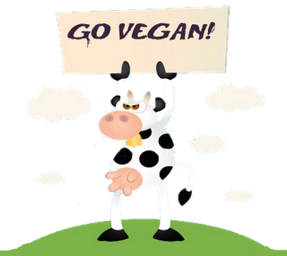
For the upcoming issue of The Yeti (check out our website...http://www.theyetionline.com/), I wrote a lovely article about what vegans and vegetarians eat for the holidays. I learned some pretty interesting things, and some of the foods I read about seemed interesting (like soy or rice based ice cream)...but it made me think. Why the hell would anyone want to give up meat???

Maybe not everyone's as big of a carnivore as I am, but the thought of never eating meat again makes me wanna cry. Have you ever had what tasted like the best burger ever? Or a delicious turkey baked in the oven with the most delicious herbs on the planet?? Or what about the classic Chick-Fil-A chicken sandwich???? How in the world could you give that up????

And for vegans it's more than just meat. It's any animal product. That means no more eggs, milk, or...CHEESE?? You won't eat CHEESE? That just sounds downright inhumane to me. Cheese is the very essence of my soul.

Anyway, I understand the benefits. Vegans and vegetarians tend to eat much healthier than fatties like me. You get a lot of benefits from a diet rich in veggies and fruits. At the same time, though, isn't it hard for you to get your daily requirement of protein? Animal protein is great for building muscle...so I guess have fun being flabby-skinny on your yoga mat.

Don't give me that "cruelty" crap either. I agree that maybe some companies don't exactly have the best facilities for their animals, but not eating meat isn't really going to solve that problem. You don't have to go meat free to protest the cruelty of some slaughterhouses. Just go free-range and find meat that hasn't been stuffed with hormones. And if you think the slaughtering act itself is inhumane, then you obviously have something wrong with you. From an instinctual standpoint, you should want to eat meat. It's what we've been doing...well, forever. Get with it.

You know what? Fine. If you don't want to eat meat, go you. Just don't shove it in everyone's face. I hate how books like Skinny Bitch try to force people into a vegan diet by claiming it's "healthier". In fact, I remember a specific line calling readers fat and pathetic (or something along those lines) if they aren't vegan.

Well, Skinny Bitch, we may be "pathetic", but at least we’re not miserable like you!

